|  |  |
| --- | --- |
| Metatag Type |  |
| Title | Trump tweets on "so-called judge" after travel ban stay |
| Source | CBS News |
| Author(s) | Reena Flores |
| Published/Uploaded | February 5, 2017, 4:09 PM EST |
| URL | http://www.cbsnews.com/news/trump-tweets-on-so-called-judge-after-travel-ban-stay/ |
| Total Images | 8 |
| Total Videos | 1 |
| Total Ext. Links | 4 |
| Total Items Comprising the Sample | 1 |
| Total Word Count | 558 |
| Contributor | DMD |

President Trump launched an early morning Twitter offensive against a federal judge Saturday after U.S. District Judge James Robart in Seattle [declared a nationwide stay on Mr. Trump’s travel ban](http://www.cbsnews.com/news/federal-judge-declines-to-extend-one-week-freeze-against-trumps-travel-ban/).

The president defended his immigration order, which prohibits refugees or any citizens from seven predominantly Muslim countries from entering the U.S., in the series of tweets. He also swore that Robart’s temporary restraining order, which effectively freezes the executive order’s most controversial provisions, would be “overturned”:

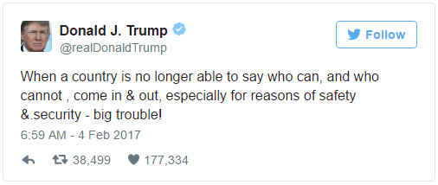

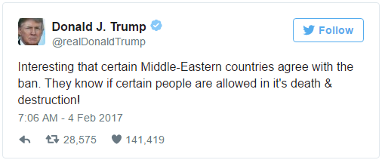

There is little evidence, however, for Mr. Trump’s claim that some Middle Eastern countries “agree with the ban.” On the contrary, many have [expressed wary dismay at the order](http://www.cbsnews.com/news/trump-travel-ban-us-allies-diplomats-cables-isis-retaliation-muslim-world/), with Iran -- one of the countries whose citizens are affected by the ban -- even seemingly threatening retaliation.

Mr. Trump later added this tweet about the “so-called judge” and his “ridiculous” opinion:

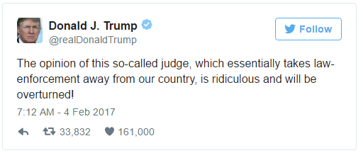

Later that afternoon, Mr. Trump tweeted again about the judge:

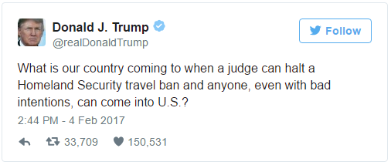

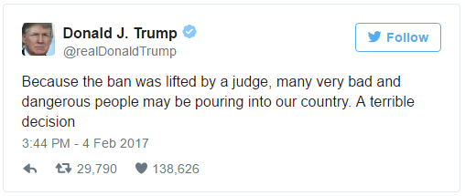

Mr. Trump continued his criticism of Robart on Sunday with two new tweets, including one saying he had instructed the Department of Homeland Security to check visitors to the country “VERY CAREFULLY” in the wake of the decision:

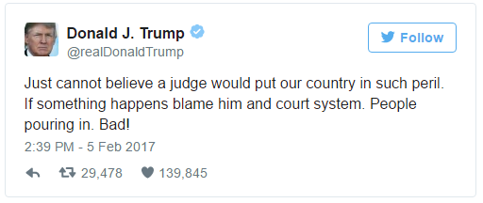

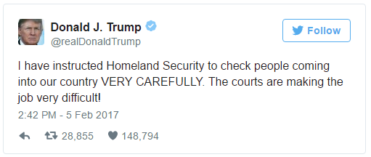

Mr. Trump has already faced criticism for his assailing comments of Judge Robart.

In a statement early Saturday, Senate Minority Leader Chuck Schumer, D-New York, denounced the slam of Robart, an appointee of former president George W. Bush.

“The President’s attack on Judge James Robart, a Bush appointee who passed with 99 votes, shows a disdain for an independent judiciary that doesn’t always bend to his wishes and a continued lack of respect for the Constitution, making it more important that the Supreme Court serve as an independent check on the administration,” Schumer said. He referenced the upcoming Senate fight over Mr. Trump’s Supreme Court nominee, Judge Neil Gorsuch, saying the president’s comments “raises the bar even higher” and said Gorsuch’s “ability to be an independent check” will be a prominent question in the judge’s confirmation process.

Late Friday, the White House said it would file an emergency stay of the order, according to press secretary Sean Spicer. The president, earlier that evening, had weighed in once more about his ban on Twitter, saying America must “keep ‘evil’ out” of the country:

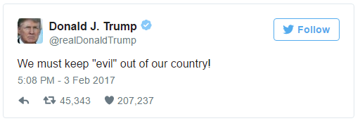

The stay on Mr. Trump’s travel ban will continue until Robart hears a Washington state lawsuit against the executive order. If the state wins, the ban will be nullified across the U.S.